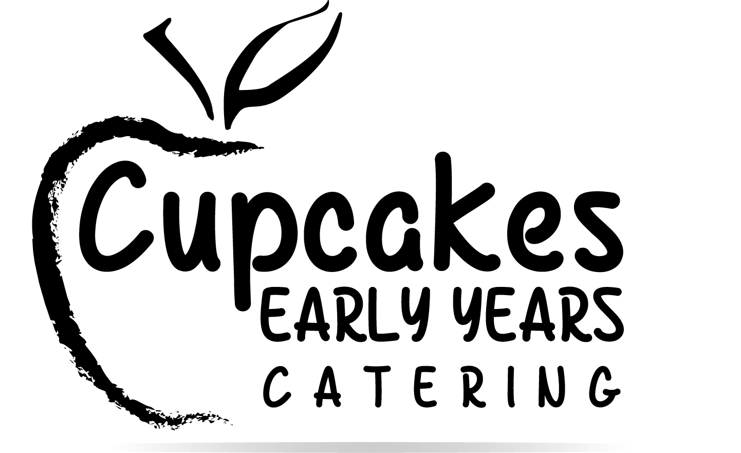
Primary School Menu February 2026 – July 2026

MONDAY TUESDAY WEDNESDAY THURSDAY FRIDAY

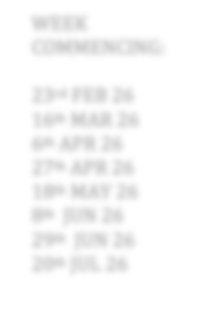

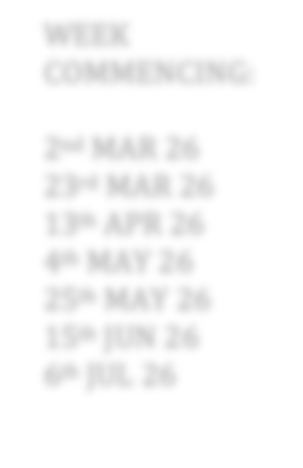

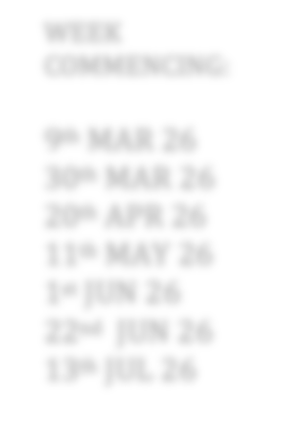
WEEK ONE

Main Option 1

Main Option 2
Cheesy Topped Vegetable Pasta (V) With Tomato, Sweetcorn & Courgette Peas
Sweet & Sour Chicken
With Peppers & Green Beans Rice & Mixed Vegetables
Sausage Rolls
With Baked Beans
Chicken Korma Curry
With Lentils Chickpeas & Mixed Veg Naan Bread
Mac & Cheese
Peas
Garlic Bread

WEEK COMMENCING:

Vegetarian
As Above Sweet & Sour Quorn Vegan Sausage Rolls Vegetable Korma Curry As Above

23rd FEB 26

Main Option 3

Main Option 4 Cold Option
Jacket Potato, Baked Beans Grated Cheddar

Cheese & Savoury Biscuits (V) Cream Cheese, Cheddar Cheese & Hummus & Side Salad
Jacket Potato, Baked Beans Grated Cheddar

Pizza Fingers (V) With Tomato Dip Side Salad
Jacket Potato, Baked Beans Grated Cheddar

Flatbreads with Ham
Side Salad
Jacket Potato, Baked Beans Grated Cheddar

Soft Rolls with Cheddar Cheese
Side Salad
Jacket Potato, Baked Beans Grated Cheddar

Wholemeal Sandwiches with Chicken
Side Salad
16th MAR 26
6th APR 26
27th APR 26
18th MAY 26
8th JUN 26
29th JUN 26

Main Course Option 5 Cold Option (V)
As Above As Above Flatbreads with Cheese (V)
Side Salad
Wholemeal Sandwiches with Cheese
As Above
Side Salad
20th JUL 26

WEEK TWO

Dessert
Swiss Roll
or Fruit / Yoghurt

Cheese & Tomato Pizza
Flapjack
or Fruit / Yoghurt

Minced Beef Hot Pot
Chocolate Cookie
or Fruit / Yoghurt

BBQ Pork
Ice Cream & Wafers
or Fruit or Yoghurt

Cheesy Topped Vegetable Pasta (V)
Vanilla Cake
or Yoghurt

Sausage & Mixed Bean Ragu

Main Option 1
Baked Beans
With Potato, Courgette, Peas
Crusty Bread
With Mixed Vegetables New Potatoes
With Tomato, Spinach & Peas Carrots
Pitta Bread

WEEK

Main Option 2 Vegetarian
As Above (V) Quorn Mince Hot Pot (V) BBQ Quorn (V) As Above Vegan Sausage & Mixed Bean Ragu

COMMENCING:

Main Option 3 Jacket Potato

Main Option 4 Cold Option

Jacket Potato, Baked Beans Grated Cheddar

Cheese & Savoury Biscuits (V) Cream Cheese, Cheddar Cheese & Hummus & Side Salad

Jacket Potato, Baked Beans Grated Cheddar

Bagels with Ham
Side Salad

Bagels with Cream Cheese (V)

Jacket Potato, Baked Beans Grated Cheddar
Tortilla Wraps with Chicken
Side Salad

Tortilla Wraps with Cheese (V)

Jacket Potato, Baked Beans Grated Cheddar
Wholemeal Sandwiches with Ham
Side Salad

Wholemeal Sandwiches with Cheese

Jacket Potato, Baked Beans Grated Cheddar
Pizza Fingers (V) With Tomato Dip Side Salad
2nd MAR 26
23rd MAR 26
13th APR 26
4th MAY 26
25th MAY 26
15th JUN 26

Main Course Option 5 Cold Option (V)
As Above
Side Salad
Side Salad
(V) Side Salad As Above
6th JUL 26

Dessert
WEEK THREE

Main Option 1

Main Option 2

Swiss Roll
or Fruit / Yoghurt

Chicken Korma Curry
With Cauliflower, Butternut Squash, Broccoli & Peas
½ Jacket Potato

Fruit Jelly & Whipped Cream
or Fruit / Yoghurt

Sausages in Gravy
With Peas New Potatoes

Ice Cream & Wafers
or Fruit / Yoghurt

Pork & Vegetable Casserole With Potato, Sweetcorn & Peas Crusty Bread

Vanilla Cake
or Fruit / Yoghurt

Beef Bolognaise Pasta
Carrots

Melon
or Yoghurt

Hot Dogs Sweetcorn Ketchup

WEEK

Vegetarian
Quorn & Vegetable Korma Curry (V) Vegan Sausages in Gravy Quorn & Vegetable Casserole Quorn Mince Bolognaise Vegan Hot Dogs (V)

COMMENCING:

Main Option 3 Jacket Potato

Main Option 4 Cold Option

Jacket Potato, Baked Beans Grated Cheddar

Tortilla Wraps with Ham

Jacket Potato, Baked Beans Grated Cheddar

Pasta Twists with Herby Tomato Sauce

Jacket Potato, Baked Beans Grated Cheddar

Flatbreads with Ham

Jacket Potato, Baked Beans Grated Cheddar

Soft Rolls with Chicken

Jacket Potato, Baked Beans Grated Cheddar

Wholemeal Sandwiches with Cheese (V)
9th MAR 26
30th MAR 26
20th APR 26
11th MAY 26

Side Salad
& Grated Cheese (V)
Side Salad
Side Salad
Side Salad
1st JUN 26
22nd JUN 26

Main Course Option 5 Cold Option (V)
Tortilla Wraps with Cheese (V)
Side Salad
Flatbreads with Cheese (V)
As Above
Side Salad
Soft Rolls with Cheese (V)
Side Salad
As Above
13th JUL 26

Dessert
Swiss Roll
or Fruit / Yoghurt
Fruit Jelly & Whipped Cream
or Fruit / Yoghurt
Oranges
or Yoghurt
Vanilla Cookie
or Fruit / Yoghurt
Flapjack
or Fruit / Yoghurt

